Richard Ibbitt’s Biographical Data

Dr Richard Ibbitt was born in Sheffield, England, in 1945. He graduated with a Civil Engineering degree from Imperial College, London, in 1966, and his Ph.D. in Engineering Hydrology from the same institution in 1970. He joined the NZ Ministry of Works, Water and Soil Division in 1970. From 1970 to 78, he carried out hydrological research and led the team that conceived and built the first version of country’s hydrological archive. In 1978, he moved to the Hydrology Centre at Christchurch, where he carried out a variety of hydrological research projects primarily related to catchment modelling. He played a lead role in the integration of the Hydrology Centre into NIWA when the latter was formed in 1992. He worked at NIWA, Christchurch till his retirement in 2010.
Dr Ibbitt’s reminiscing is available in seven segments. Richard was at the forefront of NZ’s first hydrological data archival system. In his interview, he shared the joys, challenges, and lighter moments of his work.

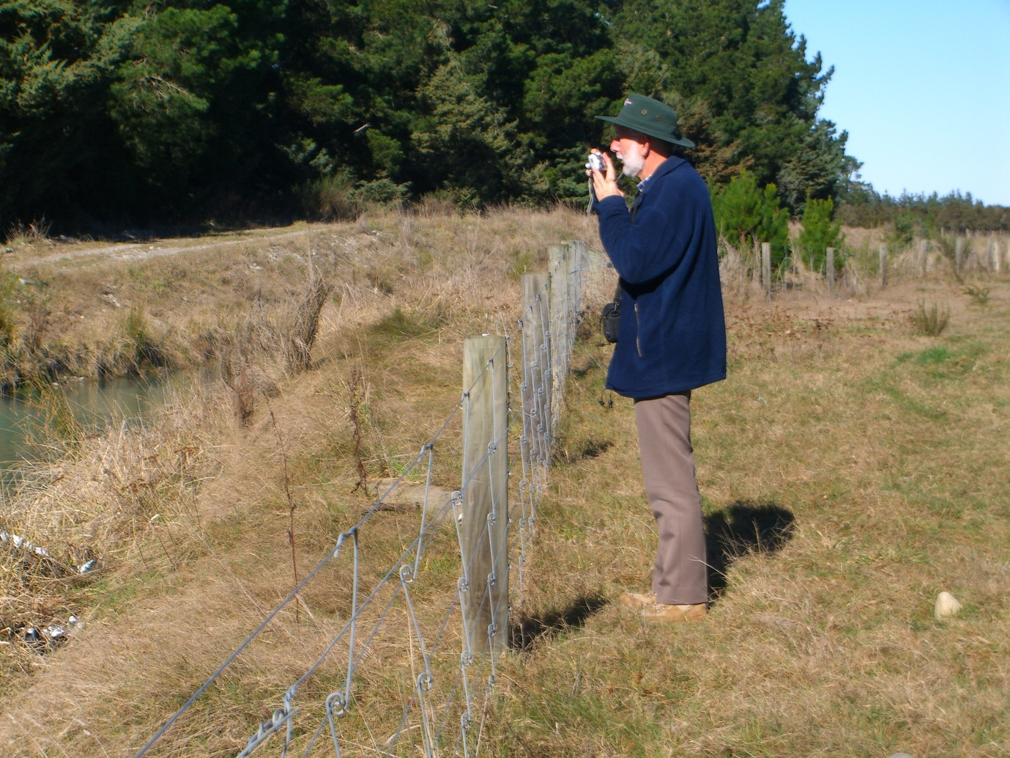
Dr Richard Ibbitt (Photo: MS Srinivasan)

